Vote YES on Article 4 at the October 10th Town Meeting
Support Our Seniors!
[This article was written by Josh Morse, Maynard resident and Public Buildings Commissioner]

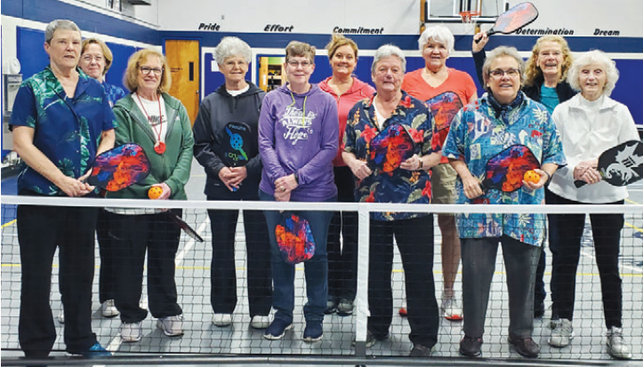
Many people have seen me advocating for the Green Meadow School Project, and while that is very important to Maynard, there is an equally important article on the October 10th Town Meeting agenda. Article 4, which directly follows the Green Meadow article, is a Citizen’s Petition requesting a free cash appropriation to cover a lease of property in the Mill & Main complex for use as a Senior Center. To be clear, this request would not have resulted in an increase in taxes. However, a subsequent ruling by the Massachusetts Department of Revenue declared that the article cannot be voted on as a binding article, to be enacted and funded as written.
The petitioners did an excellent job showing community support to secure an appropriately sized Senior Center. We can use this valuable opportunity to vote yes on Article 4 as an advisory petition and give the Select Board and Finance Committee members a clear message that this initiative has broad backing by town residents.
This petition is really about residents advocating for an appropriate space for Maynard’s senior adult population. The Town of Maynard has 3,083 residents 60 years of age and older. This represents 37% of the residents that are of voting age.
(over)
Maynard’s older adults represent the largest and fastest growing demographic in town. The Massachusetts Department of Elder Affairs states that communities should have 4-5 square feet per senior citizen dedicated within the Senior Center. At present, the space that is provided at the golf course provides only 6 square inches of space per senior citizen. Nearly every comparable community in the state is providing more space for their older adult populations.
The current 1,600 square foot space in the golf course clubhouse was intended to be an interim location back in 2013. The space is woefully undersized for the growing programs and services that are critical to the older adult population in Maynard. To meet the needs of the current population, Maynard should have a 12,332 – 15,415 square foot Senior Center. Seniors clearly need more than what the clubhouse has to offer.
I ask that you vote yes for article 4 on October 10th as an advisory statement of support. I believe it is important that the Board of Selectmen and Finance Committee hear directly from the community about how much we appreciate and respect the older residents who helped build and maintain the incredible community we love. This is not to say that the Selectmen and Finance Committee members don’t support our seniors. They have been very supportive over the years. However, there are always many other competing needs for available funds within the Town’s budget. This vote is an opportunity to give our elected and appointed officials the support they need to help make decisions that are in line with our values as a community.
Maynard’s older adult population have given so much to Maynard over the years. We must provide opportunities for them to stay engaged and be active members of the community. They need a place to maintain community connections, take part in critical programming, and avail themselves of important services. It’s time to give Maynard seniors the same opportunities that other communities in the Commonwealth provide.
For those of you who might say that you don’t use the Senior Center, nor would you ever, I offer the following. In my career I have visited more the 40 Senior Centers. I’ve spoken with thousands of Senior Center users. Not one of them ever imagined using a Senior Center. Until they did. Life throws curve balls at us all. It could be the loss of a loved one, or an injury, or an illness. There is a myriad of reasons why seniors gravitate toward Senior Centers. For those that use COA services, the Senior Center quickly becomes a critical part of their daily lives.
Again, I ask for your support in voting yes to Article 4. It is an essential need that will pay incredible dividends for the entire community.
………………………………………………………………………………………………………
Care to stay informed? Sign up for our listserv at maynardseniors@gmail.com

