HISTORICAL TIMELINE:
Council on Aging and the Maynard Senior Center

Massachusetts State Legislature – Acts and Resolves of 1956, Chapter 495: Councils on Aging were established –
Chap. 495 An Act authorizing cities and towns to establish local councils for the aging and to appropriate funds therefor. Be it enacted, etc., as follows: Section 1. Chapter 40 of the General Laws is hereby amended by inserting after section 8A the following section : - Section 8B. A city by ordinance or a town by bylaw may establish a council for the aging for the purpose of carrying out programs designed to meet the problems of the aging in co-ordination with programs of the council for the aging established under section seventy-three of chapter six. The council may appoint such clerks and other employees as it may require. Section 2. Section 5 of said chapter 40 is hereby amended by inserting after clause (48), inserted by section 1 of chapter 716 of the acts of 1955, the following clause: - (49) For the purpose of conducting programs dealing with problems of the aging and to promote facilities for the health, education, welfare and recreation of the aging, as authorized by section eight B, not in excess of five hundred dollars annually. Approved June 28, 1956. by Massachusetts General Law, Section 8B, Chapter 40.

Eighteen years later, in 1974, Maynard voted to establish a Council on Aging. Activities and classes were non-existence during the first 20 years of the Senior Drop-In Center and seniors were encouraged to attend centers in other towns for enrichment. Some meals were provided during the Drop-In hours.

Historical Timeline of Senior Services in Maynard – 1975 to present:
1975 – In the COA’s first year of organization, a group of senior citizens organized the “ Drop-In Center” in the UCC basement room. “Recreation for the Elderly” consists of occasional bus tours.
1976 – The COA added a Blood Pressure Clinic. The minister at the UCC sponsored the senior Drop-In-Center. Coffee and light refreshments were served, and attendance averaged 70 per week. The High School Home Economics teacher cooked a full turkey dinner at Thanksgiving.
1977 – Digital Equipment Corp. donated a transportation van. Anyone who wished to attend classes was encouraged to go to the Stow Senior Center. Minuteman Home Care Corp. started a hot meals program at the Elks for 40 participants. About 30 home-delivered meals were also delivered by volunteer drivers. $1,628 was appropriated by the Selectmen for membership in the Minuteman Home Corporation.
1978 – A discussion about raising funds for a senior center began.
1979 – The Maynard Housing Authority received a grant for more elderly housing.
1981 – A Maynard Nutrition Site was established at the Will Dodd Boys & Girls Club. Hot meals were served Monday through Friday, and seniors were welcome.-
1980 – Money was provided (by the town? the COA?) for a meeting room for seniors in the new complex at Concord Street Circle.
1986 – The first set of by-laws was adopted by the COA. A formula grant from the Executive Office of Elder Affairs, in the amount of $2,729, was used for office expenses, newsletter expenses, and Drop-In expenses. Still no dedicated Senior Center, thirty years after the Acts of 1956. Senior activities included a flu clinic, card playing, socializing, knitting, and a light lunch Monday through Friday.
1996 – The COA worked closely with the Senior Citizen Club. Maynard High School donated the monthly printing of the newsletter. Activities include a podiatry clinic, S.H.I.N.E., a transportation van, and sponsored the Tuesday Drop-In-Center.
1999 – (photo of the Drop-In group at the UCC, organized by the senior members)
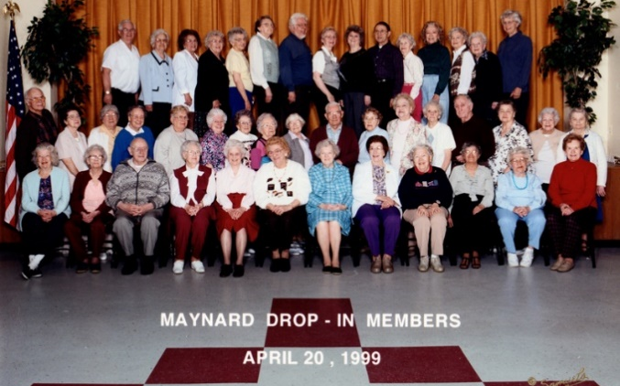
2001 –Senior citizen programs are patched together in a variety of public and private spaces around town as Maynard had not funded a Senior Center, forty-five years after the Acts of 1956. Strength, mobility, and flexibility sessions are conducted at Concord Street Circle.
2002 – Dedicated space was provided for senior activities in the basement of Clock Tower Place. From Director Joe Mullin: … Hi Peg, I'm almost positive in was in the late summer/early fall of 2002. I did arrange the whole thing----with my Mother, Alice Mullin, 90 years young, urging me on. On the day we opened we had a huge reception in our cafeteria with a crowd of X---200--250--people in attendance. What I cannot recall is the date the seniors moved out! We also hosted and housed David Hull and the Council on Aging Director---in a connected office within the senior center. At some point the Maynard-Concord Open Table lost their lease at the Maynard Union Congregational Church, and we picked up the Open Table weekly Monday night supper, and the day-to-day free-of-charge grocery store for the town [for about 8 years?] They left when our mortgage holding bank started closing in on us a short time before our Anchor Tenant--Monster.com--moved to the Biogen Building on Rt. 128/Rt. 20 in Weston.
The space served as office space, a durable medical equipment storage space, and room for a few seniors to gather each day. Formal programming and outside classes were non-existent.
2005 – The Senior Citizen’s Center is open at CTP from 10am to 1pm.The Senior Center is staffed entirely by volunteers and furnished with donated items and crafting supplies. The Department of Elder Affairs funds the printing and postage for the newsletter. Financial support of the transportation van was provided by the Senior Citizen’s Club, who held craft fairs and bake sales to raise money.
2008 –Activities at the Senior Citizen’s Center include organ lessons, card playing, movies, and exercises. Tax preparation service is added. Crafts, “good speakers” and card playing, along with exercises, movies, cribbage, and use of computers fills the schedule. Formal classes in other discipline are not yet offered, except for line-dancing at Concord Street Circle. The Drop-In-Center at the church offers a reasonable priced catered lunch. The Elder Affairs Formula Grant allows $7.00 per senior.
2013 – The Senior Center was open from 9:00am to 1:30pm. Activities include “Conversation, computers, card games, crafts, exercise equipment, chair exercises, and informative speakers”. A Community Life Center study was conducted, in part to address the needs of seniors. The study was minimally addressed. Light refreshments are served on Fridays. Line dancing is available at Concord Street Circle/
2014 – Clock Tower Place management requested the COA and Senior Citizen’s Center to vacate their space in the Mill because of an environmental clean-up. Town officials decide to temporarily relocate the COA office and the first ever Maynard town-funded Senior Center at 50 Brown Street at the rear of the golf course clubhouse. Renovations were made. From the establishment of Councils on Aging – per the Massachusetts State Legislature Acts and Resolves of 1956, Chapter 495 – until the first official Maynard Senior Center, fifty-eight years passed by. It had been a very long wait for Maynard seniors, many of whom never enjoyed activities in their new first facility.

Miscellaneous News Articles on File at the Maynard Historical Society:
